1 Analysis
1.1 The project identification and background
Formula One is the highest class of worldwide racing for open-wheel single-seater motorsport. Teams first design their cars in accordance with a set of technical regulations and compete by racing these cars racing tracks worldwide. To maximize performance in races, teams conduct extensive research and data analysis to develop the most optimal strategy for the races.
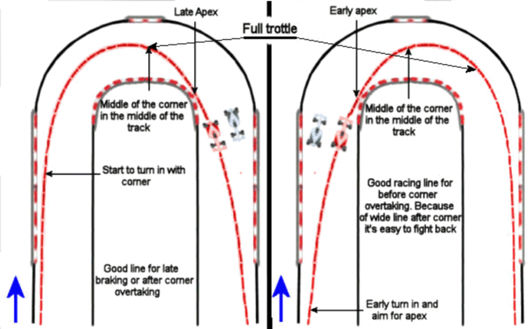
One important aspect of a race is the “Qualifying session”, during which drivers attempt to set the fastest lap time without directly racing other drivers. The results determine where they start on the grid for the main race. To develop an ideal strategy for this, teams must identify the fastest racing line, along with precise braking points and an appropriate driving style tailored to their car’s performance characteristics on that specific track. The determination of racing lines includes the consideration of a variety of factors. The geometric line is the shallowest arc possible through a corner. However, this is not always the most ideal line when all variables are taken into consideration. Each corner will have its own unique ideal line given the track conditions, car, and nature of the corner (long corners, hairpins, chicanes etc.).
My project aims to create simulation of F1 racing cars and then apply machine learning (ML) methods to learn the fastest path around a track using this simulation. I also plan to add the feature to allow users to draw their own unique track for the program to analyse.
To achieve this, the simulation will model an abstracted version of the physics on an F1 car using a sprite that drives around on the screen. It would also include sensors that can constantly determine the distance of the car from nearby walls. This data is used for collision detection and is also the input to the machine learning model learning model. I intend to use the Vanila Policy Gradient (VPG) algorithm along with a neural network to create a Reinforcement learning model that will learn the ideal path around the track. The goal of the model is to minimise the time taken to complete a full lap around the track (by crossing all turns and without exiting the track limits) with every episode (repetition). I also aim to design an interface to allow the user to use the cursor to draw the shape of the track and using other tools to modify track width at different points, add walls and kerbs etc. The user drawn track can be saved into a csv file and later reused.
F1 teams use software like rFpro to simulate vehicles and track conditions to a very high degree of accuracy. It is currently the “world’s most realistic, engineering-grade digital environment, featuring accurate track surface modelling, low system latency, realistic visual imagery, high frame rate and high dynamic range rendering”. However, due to lack of resources like software, data, time and knowledge, I will not cover the scope of such advanced software. I aim to model cars in a 2D birds eye view simulation. This would remove the need to model forces in the vertical plane, and I can assume no change in elevation of the track. Additionally, due to lack of accessible data of the real life F1 car, characteristics of the engine, brake, steering etc. will be based on arbitrary values. I will also not model gear shifts. All these simplifications will compromise on the accuracy of the simulation, however they make it more feasible for me to design my own machine learning model within the given time span.

rFpro What I aim for
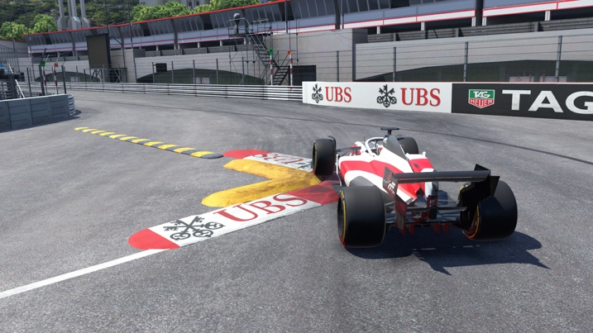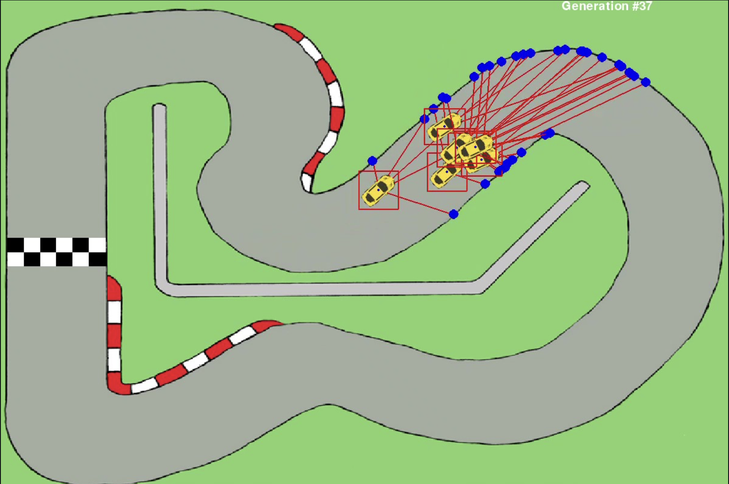

1.2 Objectives
    - Create a car sprite which can be controlled by the user.
      - User controls car’s steering using a slider (left to turn left and right to turn right) and car smoothly turns in the direction it is being steered
      - Car sprite accelerates in the direction it is facing when “W” is pressed and brakes when “S” is pressed.
      - Car obeys realistic car physics. This includes forces caused by traction, drag, rolling resistance. These forces also allow to model oversteer and understeer, and therefore drifting under sharp turning

    - Design an interface that allows the user to create their own track and save it.
      - Create an interface to let the user use their cursor to create a unique track shape.
- Create a fixed point of the track shape when left mouse button is clicked and use Bézier splines to connect fixed points.
- Allow user to modify shape of the track using the control points of the Bezier spline.
- When control key is held, connect points using a straight line instead of Bézier curve until left mouse button is clicked. This allows users to draw straights.
      - Design tools to allow the user to modify features of the track.
- User can click at a point on the track and user a slider to modify width at the point
- User can change whether there is a wall or a kerb at the track limits in individual sections
      - Allow user to save their track to a csv and retrieve saved tracks.
    - Handle interactions between the car and the track drawn by the user.
      - Use ray casting from the car to create sensors that measure distance of car from nearest wall in various directions.
      - Implement methods to ensure car is always within track limits and reset car if it hits a wall/ exits track limits.
      - Track the car’s progression through the track with respect to time
    - Design Reinforcement Learning model to control agentic cars.

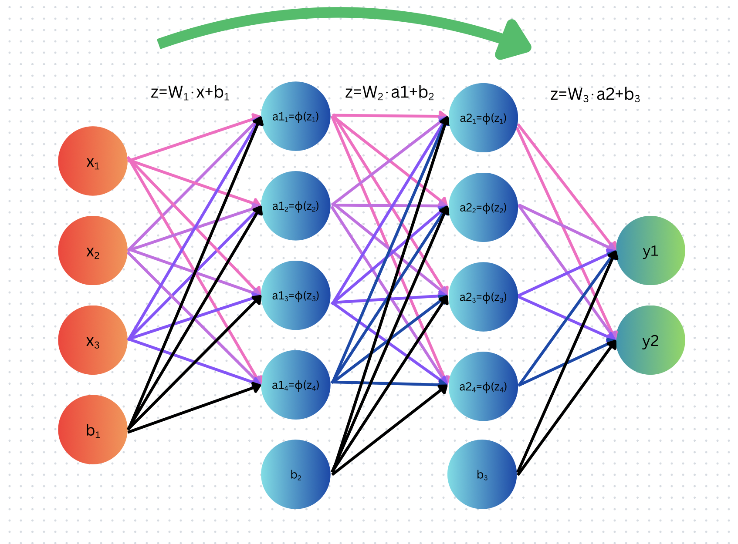
  - Research
MCQs
- What data would you like to be visible on screen during the training process
- How would you like to see the results of the trained AI

1.3.1 Interviews/Surveys
1.3.2 Technical/Skills research
1.3.3 Research Table

1.4 Prototypes

1.5 Justification of chosen solution

1.6 Initial Modelling

1.6.1 Story Board
1.6.2 Database Modelling

1.6.3 Identification of objects and object–analysis diagrams
1.6.4 Sketches and process flow of proposed output
1.6.5 Data flow diagrams (DFDs)
1.7 Analysis Data Dictionary
2 Design
2.1 Design Introduction
2.2 Hierarchy chart
2.3 Structure chart
2.4 Complex Code
2.5 Object diagrams and class definitions
2.6 Prototyping
2.7 Design data dictionary and data structures
2.8 File organisation
2.9 E-R model and diagrams, and normalised database tables
2.10 Human–Computer-interface design
2.11 System security and integrity of data

